# Analyzing HAC Reduction Penalty Likelihood

The third of the Affordable Care Act's quality incentive programs, the hospital acquired-condition (HAC) reduction program, is set to go into effect beginning in FY 2015. This program aims to incentivize the reduction of costly and often fatal harm events, estimated to cause 99,000 deaths and add as much as $33 billion to the nation's healthcare costs annually (Centers for Disease Control, 2009). While all agree that this is a worthy goal, many have raised concerns that the program's penalties will affect teaching hospitals and hospitals of 400 beds or larger disproportionately.[1] If this is the case, the program may have the unintentional consequence of systematically taking funds from hospitals that already face resource shortages, leading to poorer outcomes for vulnerable communities.

The Essential Hospitals Institute is interested in determining the effect of this program on the members of America's Essential Hospitals specifically and, more generally, those hospitals that have made it their mission to care for the nations' vulnerable populations. We begin by investigating the concerns raised by the American Hospital Association (AHA) using CMS' own predictions recently released in the FY2015 Inpatient Prospective Payment Proposed rule. We then move on to analyze the effect of the program on members of America's Essential Hospitals. Finally we explore further relationships between patient acuity and HAC reduction program penalties.

## Methods

This study was conducted using preliminary data from CMS' FY2015 Inpatient Prospective Payment Proposed rule. We utilized demographic data gathered as part of the AHA annual survey of members, to examine the expected penalties under the program by size, teaching status, membership in America's Essential Hospitals, and transfer adjusted case-mix index. *P* values for all statistical tests are 2-tailed and alpha is set at 0.001. Analyses were performed using R version 3.0.2 and R Studio version 0.98.501.

## Results

Recently released preliminary data from CMS' FY2015 Inpatient Prospective Payment Proposed rule estimates that 772 hospitals will be penalized under the program with a one percent reduction in hospital payments from the Centers for Medicare & Medicaid Services.

This estimation shows that 38.12 percent of hospitals with 400 beds or more will be penalized. Teaching status, defined in our analysis as being a member of the Council of Teaching Hospitals, faced penalties at a rate of 54.47 percent.

A chi-square test of independence was performed to examine the relation between a hospital size of 400 beds or greater and penalties under the HAC reduction program. The relation between these variables was significant, X2(1, N = 3263) = 68.17, p <.001. Larger hospitals were more likely to be penalized under the program.

A similar chi-square test examining the relationship between teaching status and penalties also returned significant results, X2(1, N = 3263) = 150.10, p <.001, indicating that teaching hospitals were also more likely to be penalized under the program.

## 

**Figure 1: Comparison of Penalties: Teaching Hospitals**

**Figure 2: Comparison of Penalties: Hospitals with 400 beds or more**

Given these finding it is not surprising that Essential Hospitals, comprised of many large academic medical centers, are also disproportionately affected by these penalties.

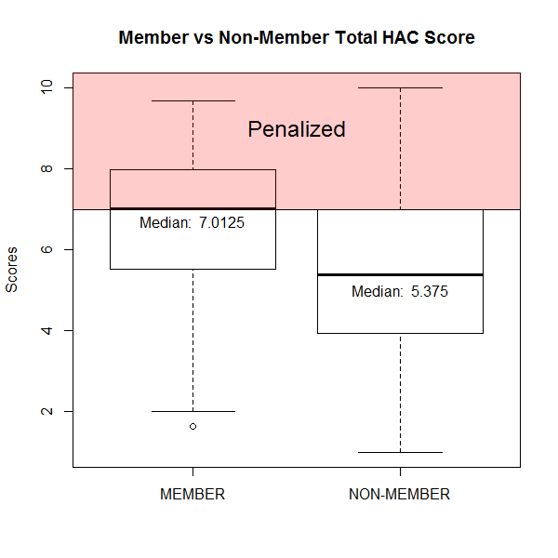

**Figure 3: Comparison of Penalties: America's Essential Hospital Membership**

## Discussion

|  |  |  |  |  |
| --- | --- | --- | --- | --- |
| Transfer Adjusted Case-Mix Index Grouper V31 | | | | |
|  | 1st Quartile | 2nd Quartile | 3rd Quartile | 4th Quartile |
| Not Penalized | 686 | 641 | 628 | 565 |
| Penalized | 134 | 166 | 188 | 255 |
| Percent Penalized | 16.34% | 20.57% | 23.04% | 31.10% |

1. AHA comment letter: